Assignment – 26-03-2025

-----------------------------------

Q 1. How to delete empty lines in a file?

A- sed '/^$/d' input_file > output_file

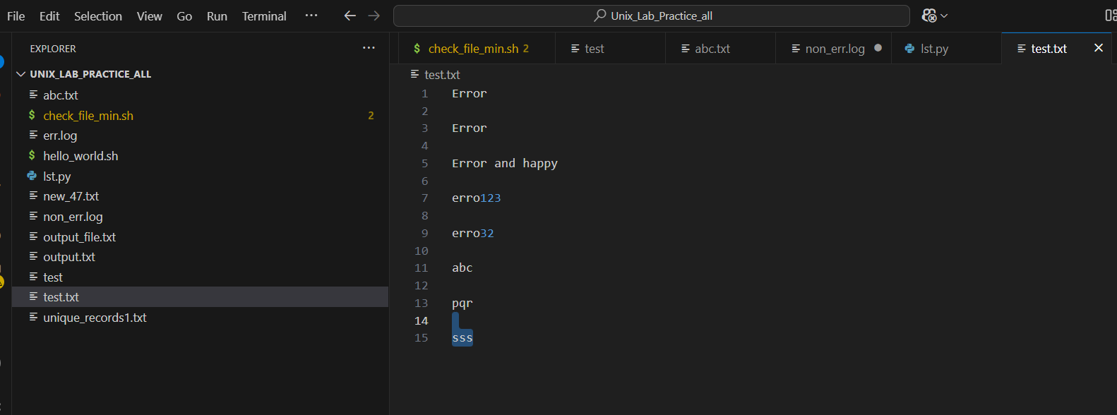

o/p-

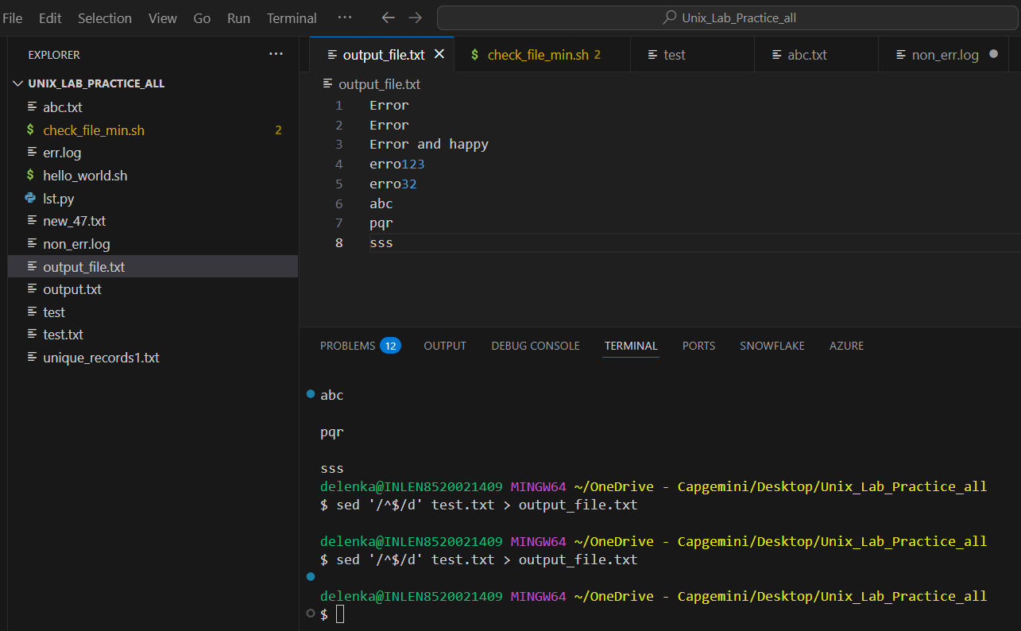

A- awk 'NF' input_file > output_file

o/p- 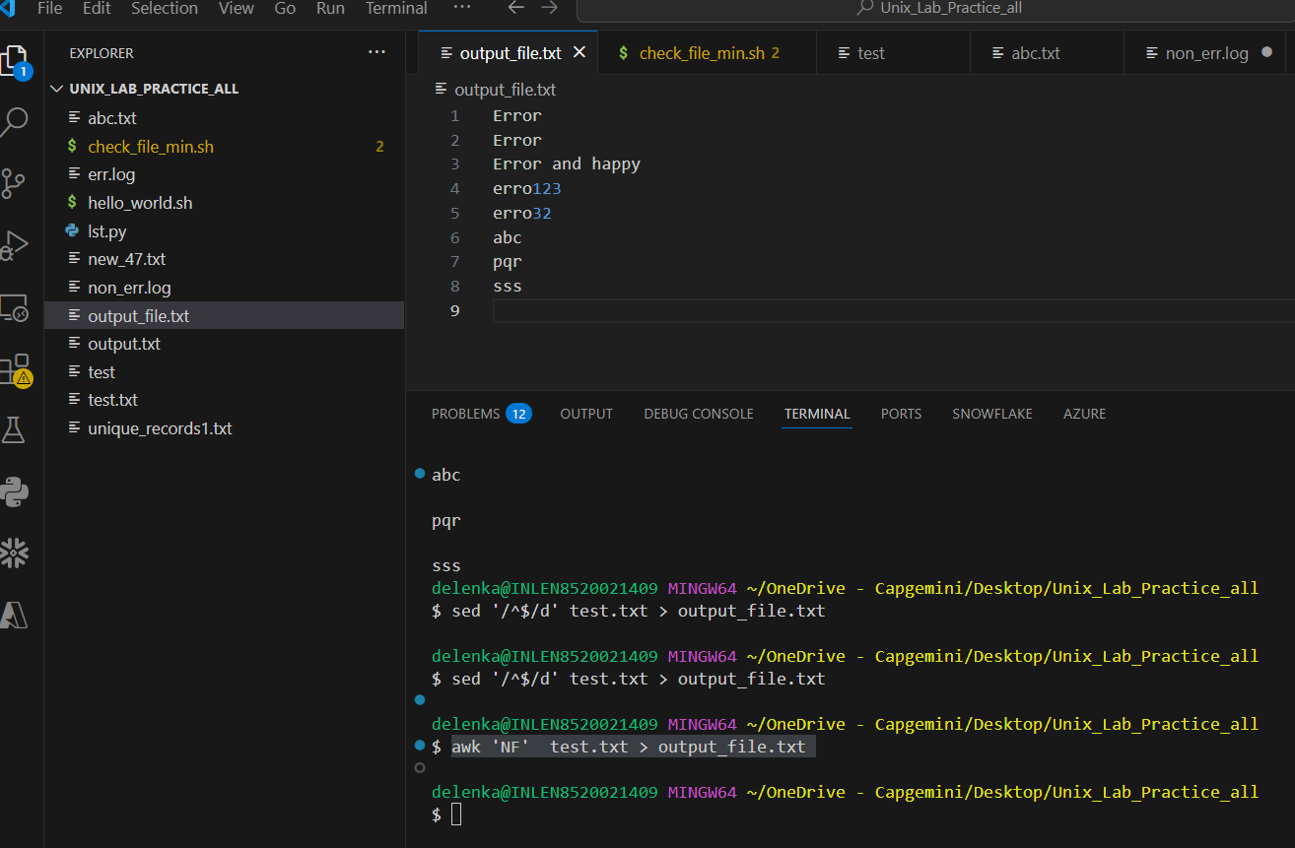

grep -v '^$' input_file > output_file

o/p-

Q 2. How to print the hidden files?

A- ls -a

o/p-



Q 3. How to display the files in a directory, size less than 4 MB?

A- find . -type f -size -4M

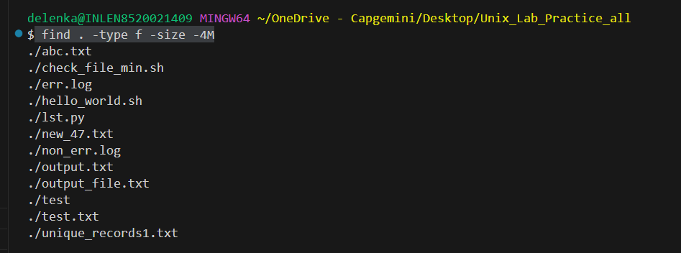

Q 4. How to transfer files from one application Server to another server?

A- scp username@source_host:/path/to/source/file username@destination_host:/path/to/destination/directory

Q 5. How to connect to DB from Unix Server?

A- sqlplus -s username/password@hostname:port/service_name

Q 6. What is the first line of the Script (shebang) and what it denotes/indicates?

A- The first line of a script, known as the **shebang** (or **hashbang**), is used to specify the interpreter that should be used to execute the script.

#!/bin/bash – bash script

Q 7. How to run a process in background and what is it’s advantage?

A- nohup ./check_file_min.sh &

Running a command in the background and ensuring it continues running even if the terminal is closed

Q 8 . How do you find the number of occurrences of the word in the file? (wc -w)

A- grep -o "[Ee]rr.*" abc.txt | wc -l

sed -n '/[Ee]rr.*/p' abc.txt | wc -l

awk '/[Ee]rr.*/ {count++} END {print count}' abc.txt

o/p-

Q 10. How do you delete the files older than 10 days?

A- find . -type f -mtime -10 -exec rm {} \;

Q 11. How do you find the line count for the matching pattern?

A- grep -o "[Ee]rr.*" abc.txt | wc -l

sed -n '/[Ee]rr.*/p' abc.txt | wc -l

awk '/[Ee]rr.*/ {count++} END {print count}' abc.txt

o/p-

Q 12. Write a command to print the lines that ends with the word "specific_word"?

A- sed ‘s/^$/INCLUDE$/’ abc.txt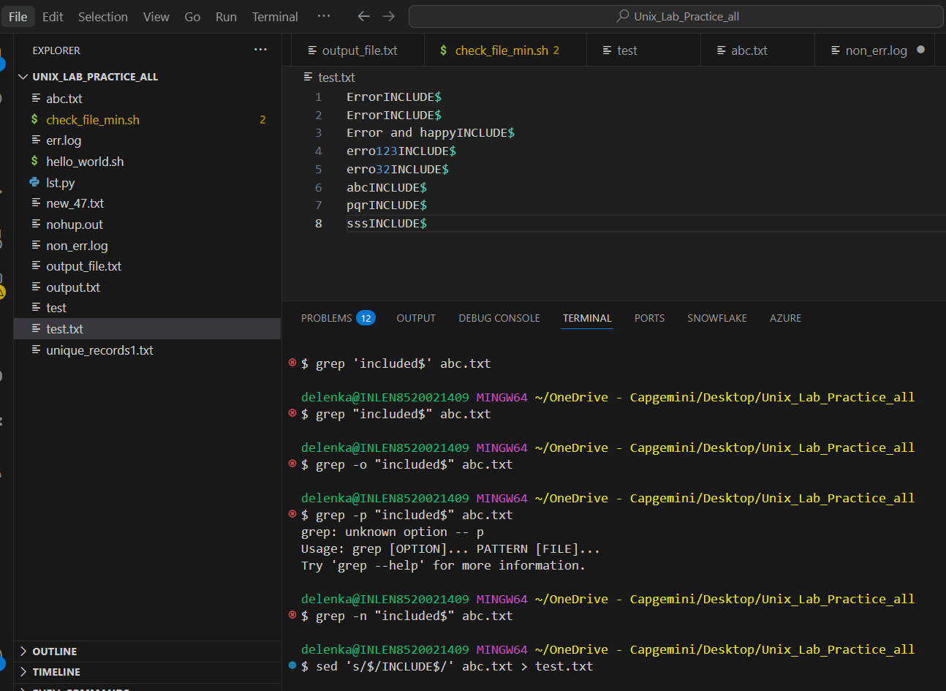

Q 13. Write a command to print the lines matching with exact word?

A- sed -n '/1345778888.*/p' test1.txt

sed -n '/1345778888/p' test1.txt

grep -n "1345778888" test1.txt

awk '/1345778888/' test1.txt

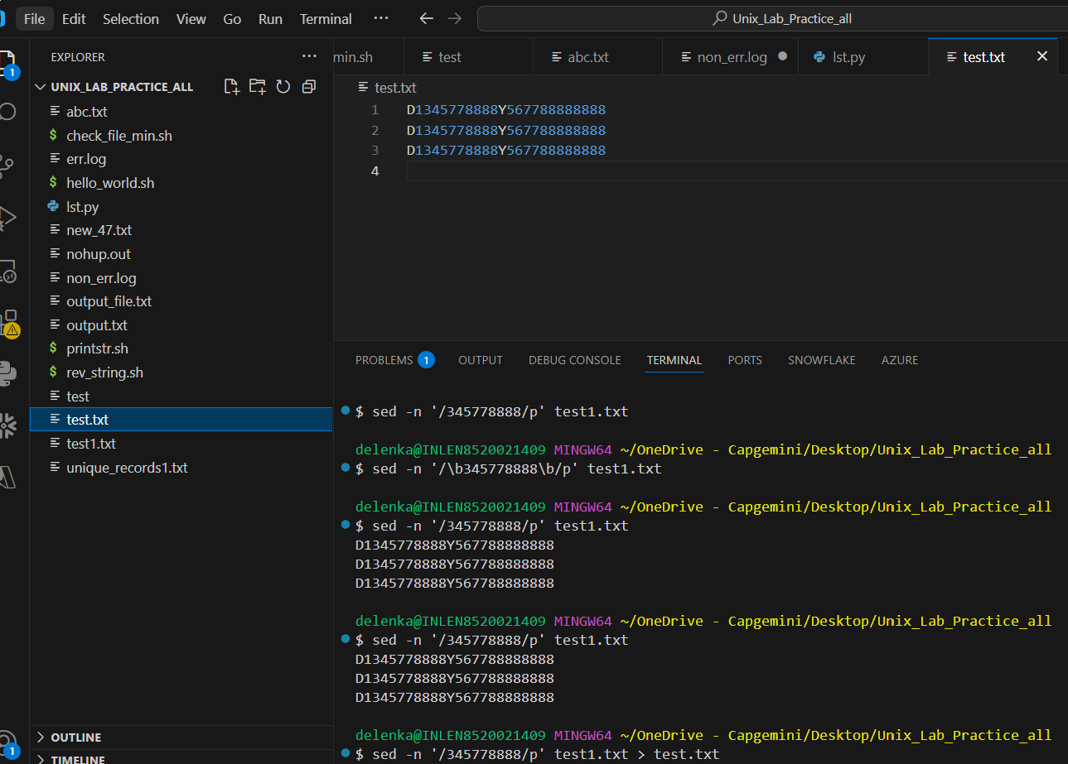

Q 14. Match all words starting with “Particular String”.

A- awk '/[Ee]rr.*\w*/' abc.txt

sed -n '/[Ee]rr.*\w*/p' abc.txt

grep -no '[Ee]rr.*' abc.txt

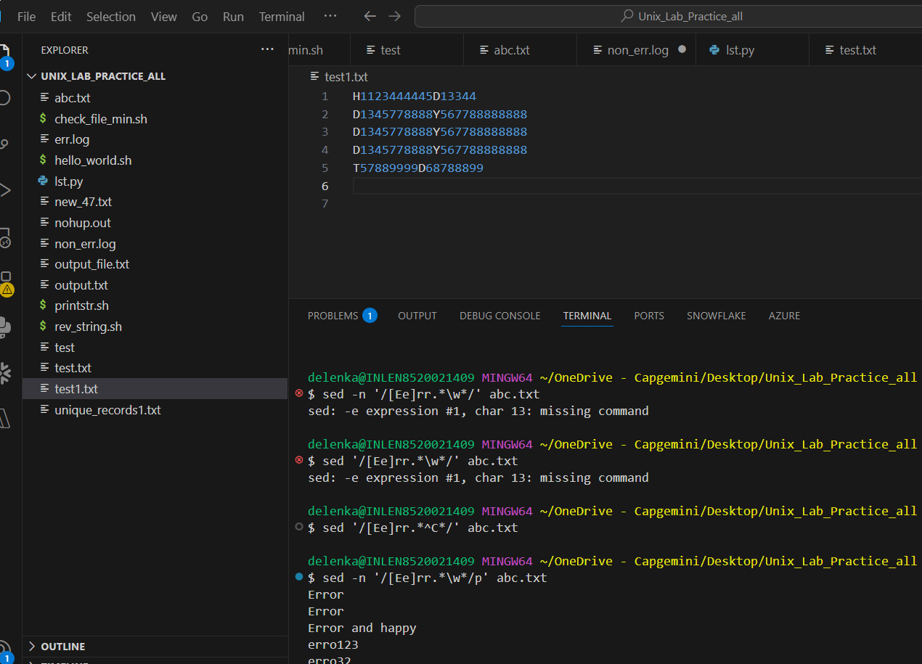

Q 15. Match all pattern which starts with q and doesn’t follow by u?

A- grep -o '\bQ[^U]\w*\b' test1.txt

sed -n '/\bQ[^U]\w*/p' test1.txt

awk '/Q[^U].*/' test1.txt

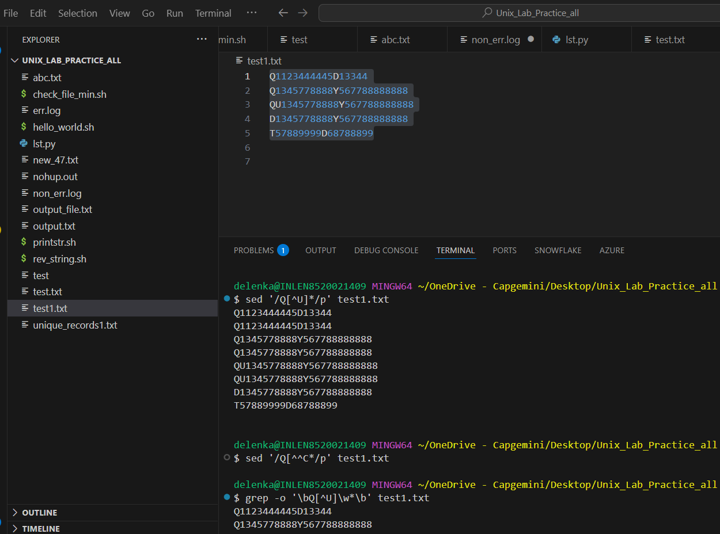

Q 16. To show below and above 2 lines of the matching pattern?

Q 17. How to zip and unzip the files?

A- zip fil1.txt

unzip file1.txt

Q 18. How to display files names which contain given word?

A- grep -rl ‘Error’ .

find . -type f -exec sed -n '/Error/{p;q}' {} \; -print

find . -type f -exec awk '/Error/{print FILENAME; exit}' {} \;

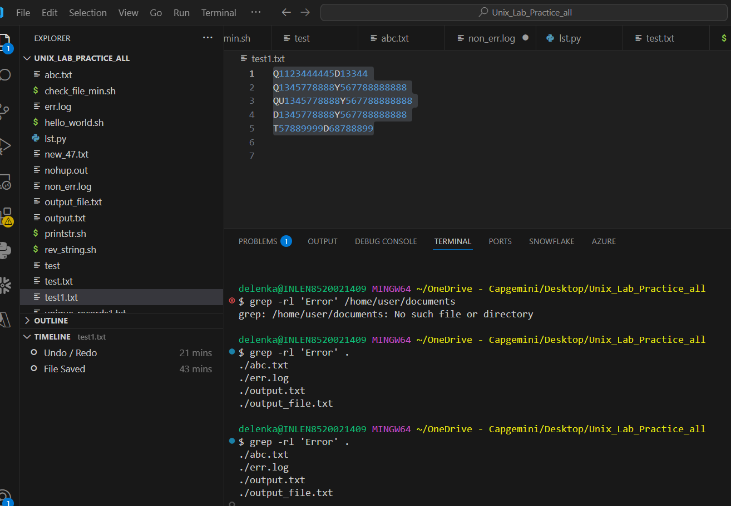

Q 19. How to search for multiple matching string in the file?

A- sed -n '/Error\|abc\|sss/p' abc.txt

grep -e 'Error' -e 'abc' -e 'pqr' abc.txt

awk '/Error|abc|pqr/' abc.txt

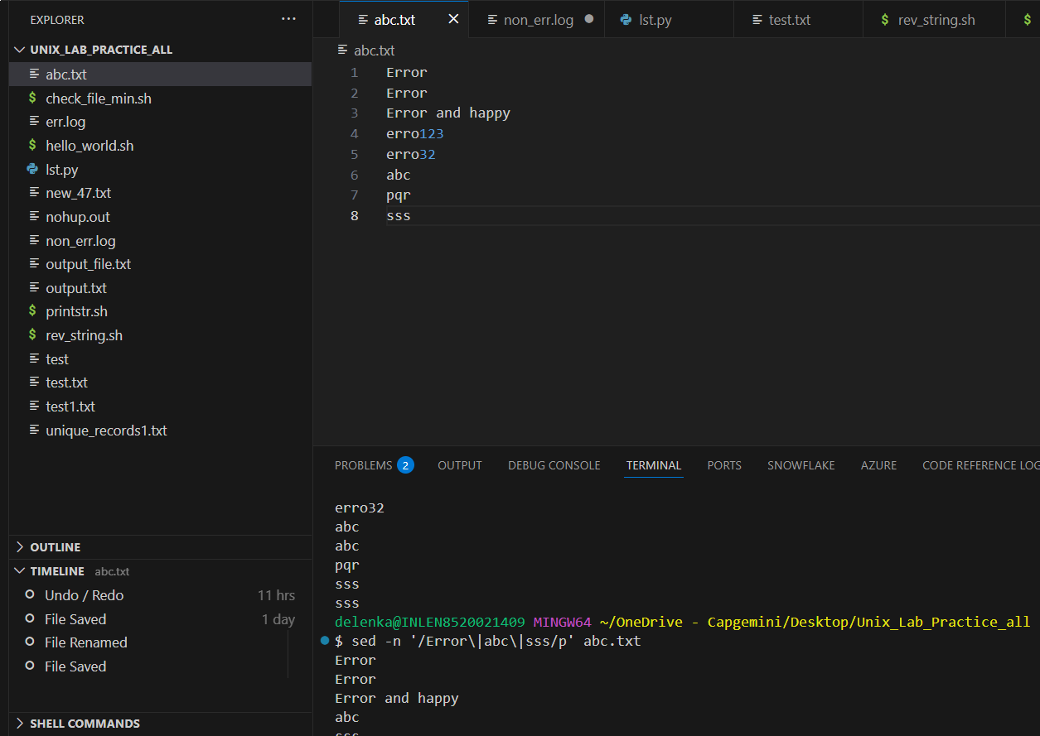

Q 20. To delete the file which is having permission 644?

A- find /path/to/directory -type f -perm 644 -exec rm {} \;

Q 21. How to change the permission of any file?

A- chmod 777 file_name.txt

Q 22. How to set default permission of any file?

A- umask 027

Q 23. What is the default permission newly created file and directory?

* A- **Files:** 666 (read and write for owner, group, and others)
* **Directories:** 777 (read, write, and execute for owner, group, and others)

Q 24. Create a 0 byte file with 477 permission?

A- touch file.txt

Chmod 477 file.txt

Q 25. If file content is space separated, then how to show only last field of the file?

A- awk '{print $NF}' test1.txt

sed 's/.* //' test.txt

Q 26. Print all input lines from filename that have more than 4 fields.

A- awk 'NF > 4' filename.txt

grep -E '([^ ]+ ){4,}' filename.txt

o/p-

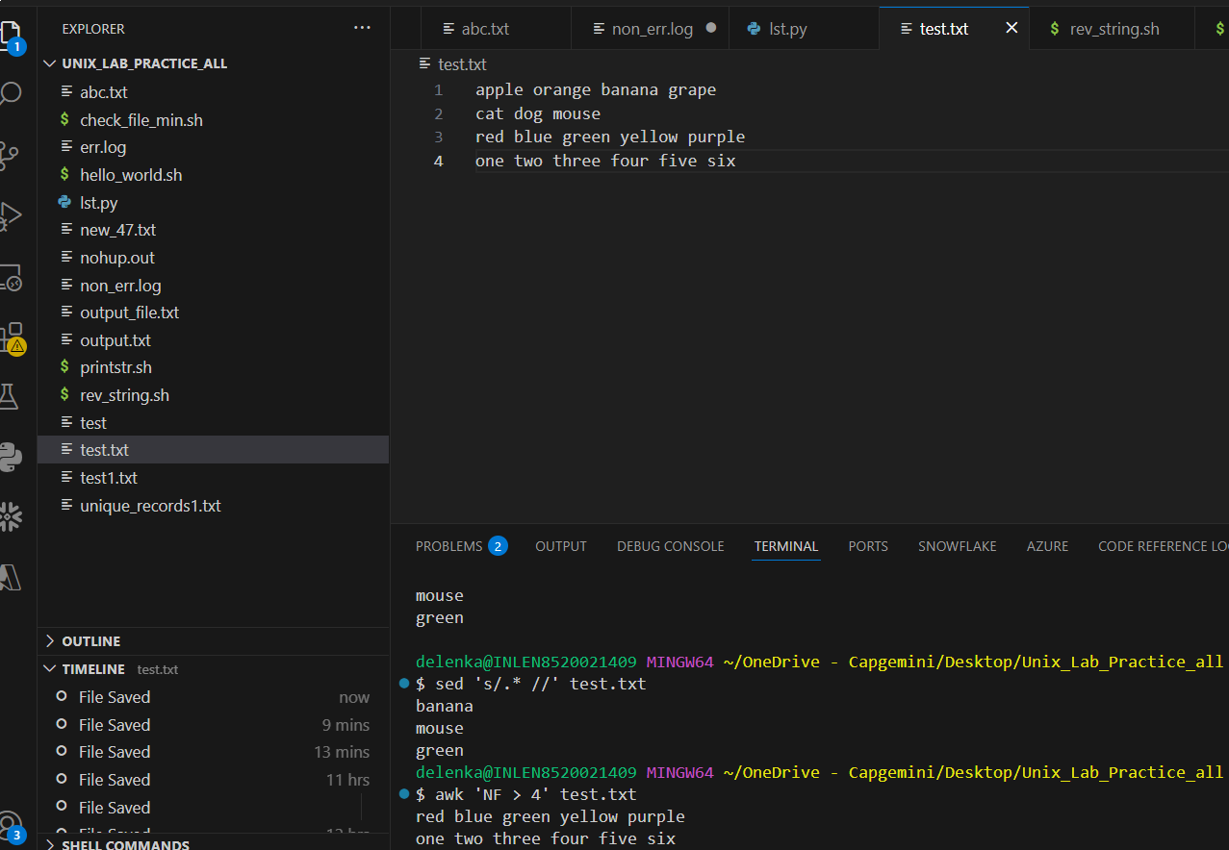

Q 27. Print the total number of lines in the filename to the screen.

A- wc -l file1.txt

awk 'END {print NR}' test.txt

Q 28. If the files having 4 fields and if any field is blank then delete that particular line?

A- sed '/^ *[^ ]* *[^ ]* *[^ ]* *[^ ]* *$/!d' filename.txt > temp.txt && mv temp.txt filename.txt

grep -v '^\([^ ]* \)\{3\}[^ ]*$' filename.txt > temp.txt && mv temp.txt filename.txt

Q 29. How to replace 4th occurrence of any pattern with given new pattern?

A- sed 's/test/exam/4' filename.txt

